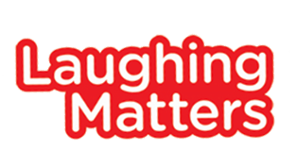

Laughing Matters – Case Study
_______________

Graham St Quintin of Nottingham was among the participants on the pilot Laughing Matters workshop course and first heard about it via the alcohol and drug recovery charity Double Impact, where he was a service user and most recently a volunteer.
“The Laughing Matters course helped me to take the next step. I had reached a point where I was in a really comfortable recovery ‘bubble’ and I needed an impetus to start moving forward again.”
It was with some trepidation that he attended the course, and was particularly wary of the final performance. With the guidance of professional comedian Sam Avery he identified material taken from his personal experiences and settled on a strategy for his performance style, a storytelling approach based on his favourite types of stand-up comic such as Stuart Lee and Richard Herring. When the final performance arrived, attended by his supportive wife Angela, he felt his fears melt away and was able to deliver an assured routine.
He concluded: “The workshops were great fun and while the performance at the end was a little nerve wracking it’s something that I am incredibly proud to have achieved. I’ve seen a lasting benefit from it too and it has expanded my comfort zone. The experience has helped me in other situations which also demand an element of performance, for example a recent job interview.”
http://www.laughingmatters.org.uk/
https://www.youtube.com/watch?v=W-ObAeVuX64
http://www.laughingmatters.org.uk/gig-gallery/

